# Lesedi Motsepe Whitewater Rafting Site Plan

1. The image file you selected for the site logo.

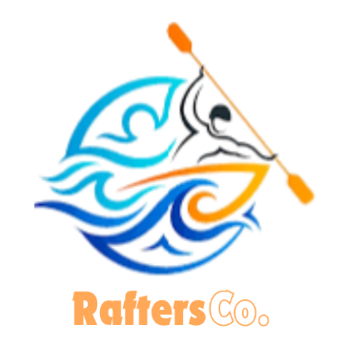

1. Write out the four (4) color labels (listed below) with the color codes you selected:
   * primary-color: Sky Blue(#8ecae6)
   * secondary-color: Blue Green(#219ebc)
   * accent1-color: UT Orange(#fb8500)
   * accent2-color : Prussian Blue(#023047)
   * Blue
2. Write out the two (2) font labels (listed below) and the names of the fonts you selected:
   * heading-font: Anton
   * text-font: Roboto
3. Provide the URL link to your color palette that you designed in coolors.co  
   Here is an example URL link:

[Create a Palette - Coolors](https://coolors.co/8ecae6-219ebc-023047-ffb703-fb8500)

https://coolors.co/8ecae6-219ebc-023047-ffb703-fb8500